Ideation Phase
Empathize & Discover

Date | 25 october 2026
Team ID | kummarip440@gmail.com
Project Name | movie ticket booking
Maximum Marks | 4 Marks

Empathy Map Canvas:
Understand the needs, frustrations, and behaviors of freelance professionals s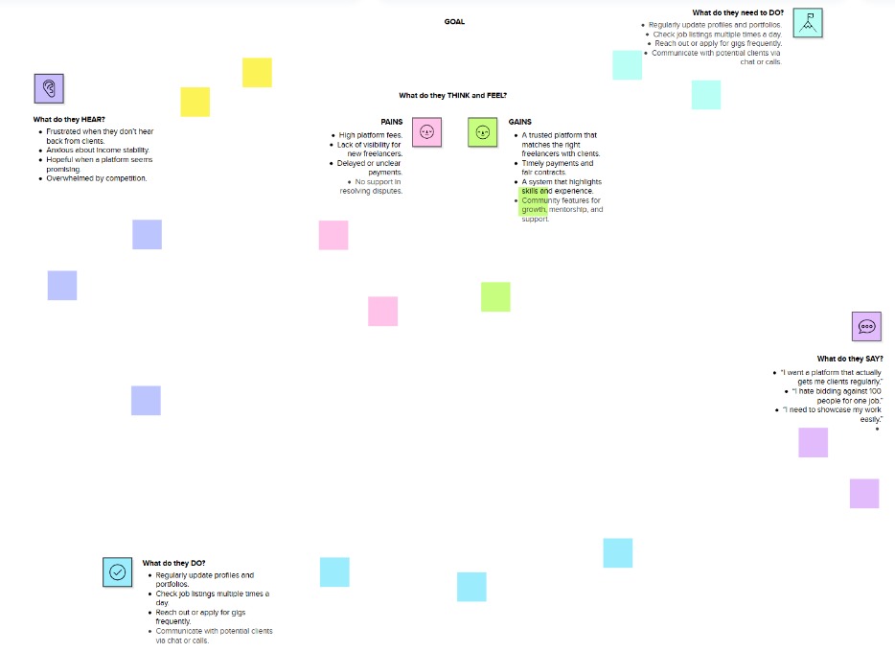seeking consistent work through a platform like Freelance Finder.

Reference: https://www.mural.co/templates/empathy-map-canvas

